Sample Lesson University Students
Trayectos Volume 1, Módulo 1
Para terminar…Lectura

This sample lesson is based on the unit about Somos estudiantes universitarios. It is written for beginner classes of university students. This lesson plan is for a 50 minutes class.

Objective:
- Learners understand, interpret, and analyze what is heard, read, or viewed on a variety of topics.
- Learners use the language to investigate, explain, and reflect on the relationship between the practices and perspectives of the cultures studied.
- Learners use the language to investigate, explain, and reflect on the concept of culture through comparisons of the cultures studied and their own.

Sequence of suggested implementation:
Agenda | Time
Antes de leer | 3-4 minutes
A leer | 3-4 minutes
Después de Leer | 3-4 minutes
Análisis | 7 -9 minutes
Lengua | 3 minutes
Curso de inglés para inmigrantes | 15 minutes
Presentations | 10 minutes
Práctica individual | 3 minutos

Handout: Modified from trayectos https://trayectos.coerll.utexas.edu/v1/modulo-1/para-terminar-lectura/, licensed under CC BY SA 4.0

I. Antes de leer
In this module, we have talked about different kinds of classes at your university and the Spanish-speaking world. In this section, we will read a short, digital text for immigrants who want to learn Spanish.

What characteristics should a course for different kinds of immigrants have? Think of one or two ideas, and then read the text to see what such a course offers in Spain.
_____________________________________________________________________________________________________________________________________________________________________________________________________________________________________________________________________________________________________________________________________________________________________________________________________________________________________________________________________________________________________________________________________________

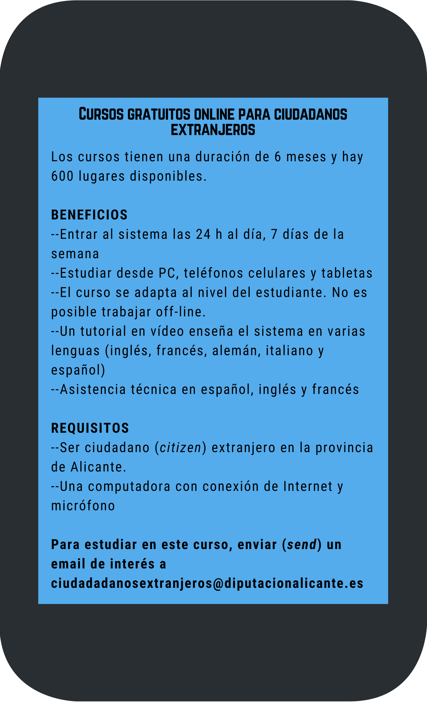
II. A leer

Attribution: By Gabriela C. Zapata. Public domain.
(Text: Modified from 600 plazas. Cursos gratuitos de español online para ciudadanos extranjeros by Marca Empleo, licensed under CC BY 4.0.)

III. Después de leer.
Completa las siguientes actividades con un@ compañer@.

Actividad A. ¿Cierto (C) o falso (F)? Decide si las siguientes oraciones son C o F teniendo en cuenta (taking into account) el contenido del texto.

1. Este curso es solamente (only) para estudiantes universitarios. C F
2. La gente toma el curso por un semestre. C F
3. El curso es en la universidad de Alicante C F
4. Las clases en el curso son en la mañana. C F
5. El curso es de lunes a domingo. C F
6. Los materiales para el curso son digitales. C F
7. Los estudiantes miran un video para saber (to know) cómo usar el sistema. C F
8. Los estudiantes de Madrid toman este curso. C F
9. En el curso, los estudiantes hablan. C F
10. La gente manda un mensaje de texto para tomar el curso. C F

Actividad B. Análisis. Contesta estas preguntas.
1.What characteristics make this course ideal for an immigrant? Why?

2. Do you believe this is a good alternative for newly-arrived immigrants? Why? Why not?

3. What might be the problems an immigrant may encounter when enrolling in this course?

4. Does this state offer similar English courses for immigrants? Do some research online to find out.
Actividad C. Lengua.
Busca tres cognados. Did these words help you understand the text? What other strategies did you use to read it?
____________________________________________________________________________________________________________________________________________________________________________________________________________________________________________________________________________________________________________________________________________________________________________________________________________________________________

Actividad D. Curso de inglés para inmigrantes.
Ahora con tres o cuatro compañer@s, create an ad similar to one we read to advertise an English course for immigrants from Spanish-speaking countries. You can add information on different types of classes (e.g., conversación, cultura, historia, etc.), and have a mixture of online (en línea) and face-to-face (en persona) classes. You need to have all the sections that appear in the original text. You can also add a logo to your course

Práctica individual:
Go to this website and complete the task. https://trayectos.coerll.utexas.edu/manual-de-actividades-lectura/

